2021-2022 COURSE SYLLABUS
BIOLOGY

Teacher: Christie Lowell | Phone Number: 404-802-3000
Room Number: C315 | Email: cxlowell@atlanta.k12.ga.us
Semester: Fall 2021 | Tutorial Days: Monday
Textbook: Miller Levine Biology | Tutorial Hours: After school
Website: christielowell.weebly.com | Tutorial Location: C315

Course Description:
The Biology curriculum is designed to continue student investigations of the life sciences that began in grades K-8 and provide students the necessary skills to be proficient in biology. This curriculum includes more abstract concepts such as the interdependence of organisms, the relationship of matter, energy, and organization in living systems, the behavior of organisms, and biological evolution. Students will investigate biological concepts through experience in laboratories and field work using the processes of inquiry. Our goal is to enhance student’s skills and further develops the concepts on interdependence of organisms, energy flow in living systems, and biological evolution.

A state mandated Milestones End of Course Assessment is required and counts as 20% of the student’s second semester grade

Course Content Standard - (www.georgiastandards.org):
SB1. Obtain, evaluate, and communicate information to analyze the nature of the relationships between structures and functions in living cells.

SB2. Obtain, evaluate, and communicate information to analyze how genetic information is expressed in cells.

SB3. Obtain, evaluate, and communicate information to analyze how biological traits are passed on to successive generations.

SB4. Obtain, evaluate, and communicate information to illustrate the organization of interacting systems within single-celled and multi-celled organisms.

SB5. Obtain, evaluate, and communicate information to assess the interdependence of all organisms on one another and their environment

SB6. Obtain, evaluate, and communicate information to assess the theory of evolution.

Course Outline:

Week 1: | Unit 1: Characteristics of Life
Week 2: | Unit 1: Characteristics of Life
Week 3: | Unit 2: Molecules to Organisms: Structure and Processes
Week 4: | Unit 2: Molecules to Organisms: Structure and Processes
Week 5: | Unit 2: Molecules to Organisms: Structure and Processes
Week 6: | Unit 2: Molecules to Organisms: Structure and Processes
Week 7: | Unit 3:Heredity: Inheritance and Variation of Traits
Week 8: | Unit 3:Heredity: Inheritance and Variation of Traits
Week 9: | Unit 3:Heredity: Inheritance and Variation of Traits
Week 10: | Unit 3:Heredity: Inheritance and Variation of Traits
Week 11: | Unit 4: Biological Evolution: Unity and Diversity
Week 12: | Unit 4: Biological Evolution: Unity and Diversity
Week 13: | Unit 4: Biological Evolution: Unity and Diversity
Week 14: | Unit 5: Ecosystems: Interactions, Energy and Dynamics
Week 15: | Unit 5: Ecosystems: Interactions, Energy and Dynamics
Week 16: | Unit 5: Ecosystems: Interactions, Energy and Dynamics
Week 17:
Week 18:

Evaluation and Grading:

Course Components | Weights | Grading Scale  100-90 A  89-80 B  79-70 C  69-0 F  Not Evaluated NE
Formative Assessments (Classwork, Quizzes) | 45%
Summative Assessments (Labs, Projects, and Tests) | 55%
TOTAL | 100%

Campus Portal for Parents and Guardians: Visit - https://ic.apsk12.org/portal to view class schedules, attendance records and grades. To activate your account, visit the school to receive your login (activation key).

Schoology is a K-12 educational learning management system and an all-in-one platform for teaching, learning, assessing, and reporting grades and data. The goal for an LMS is to allow a school to have a central piece of technology to be the platform for communicating with students, teachers, families, and administration. Students access Schoology through MyBackpack.

Required Materials:
1) Writing utensils (pencils, black or blue pen)
2) Loose leaf paper (College Ruled)
3) 3-Ring binder or folder
4) Electronic device (personal or provided by the school)

School-wide Behavioral Expectations: Be present; be respectful; be responsible; be on task; be peaceful, productive problem solvers.

Classroom Expectations:
You are responsible for behavior in the classroom, which is appropriate for the class activities and is respectful of the rights, property, and comfort of others. Behavior that is disruptive to class or destructive of property will result in a phone call home and may result in a referral. Some of the more important ones are listed below:

1. Come to school every day!
2. Keep up with your belongings (including books and other supplies).
3. Show respect for yourself and others through your words and actions.

o Late Assignments: It is important that students are responsible and meet established due
dates for assignments. A late assignment is defined as work submitted after the teacher collected the assignment. All missing/not turned in assignments will be recorded in IC with an “M-Missing” designation.

Late work penalty 15%. Assignments from the first quarter submitted after the mid-semester have a 30% penalty. Late assignments submitted in the last three weeks of the semester have a 40% penalty. No late assignments accepted within a week of final exams. Late assignments will be graded before the late penalty is applied

FALL SEMESTER
When late assignment submitted | Late penalty
August 9-October 6, 2021 (mid-semester) | 15%
Assignments from August 5-October 6 submitted October 12-  November 19, 2021 (before Thanksgiving break) | 30%
Assignments from October 12-November 19 submitted late through November 19, 2021 | 15%
Assignments from August 5-November 19  submitted November 29-December 10, 2021 | 40%
Assignments from November 29-December 9 submitted late | 15%
No late assignments accepted after December 10, 2021

SPRING SEMESTER
When late assignment submitted | Late penalty
January 5-March 18, 2022 (mid-semester) | 15%
Assignments from January 5-March 18 submitted  March 22-May 6, 2022 | 30%
Assignments from March 22-May 6 submitted late through  May 6, 2022 | 15%
Assignments from January 5—May 6 submitted  May 9-May 20, 2022 | 40%
Assignments from May 9-May 19, 2022 submitted late | 15%
No late assignments accepted after May 20, 2022

MAKE-UP ASSIGNMENTS (Excused Absences): Students with an excused absence will be expected to submit missed work on or before the third class meeting after the absence. Pre-announced assignments are due upon return to school.

REASSESSMENT OPPORTUNITY: Reassessment opportunities are available for all students on tests when they scored 69% or below. There will be only one reassessment opportunity on tests. This reassessment will be a newly generated teacher assessment and the reassessment score will replace the original score.

For classes with content on Edgenuity: If the student has not demonstrated mastery of the content during the reassessment opportunity, the student will be assigned Edgenuity. The student must take the assessments in a teacher-proctored environment.

For Advanced Placement classes Reassessment opportunities are available for all students on formative assessments/quizzes only due to College Board requirements. There will be only one reassessment opportunity on assessments. This reassessment will be a newly generated teacher assessment and the reassessment score will replace the original score. Reassessment can occur during the class period, tutorials, and/or lunch-and-learn sessions (at the teacher’s discretion).

School-wide Expectations:

MASTERY LEARNING: With mastery learning, a unit of material is taught, and student understanding is evaluated before students are able to move on to the next unit. Students who have not shown mastery for a particular unit will receive feedback and support in reaching mastery. They may be given practice exercises, study guides, group work or complementary resources to help them improve and achieve mastery. Students who demonstrate mastery of the content for a particular unit are given enrichment exercises like special projects, tasks or academic games to further or broaden their knowledge of the material.

For additional help, Tutor ATL info: https://tutoratl.org

PROGRESS REPORTS: Parents and guardians are informed when students are making unsatisfactory progress in classes. Poor performance will be reported to parents and guardians as soon as problems are evident. Progress reports with plans for remediation will be provided for all students making unsatisfactory progress, and parent-guardians conferences must be scheduled. Unsatisfactory grades should never come as a surprise to parents, guardians, or students. Also, see Board Policy Administrative Regulation IHA-R(1) under “Students in danger of not meeting academic expectations” for further information. Teachers will:

- Contact parents/guardians early in the semester if academic, attendance, or behavioral difficulties are apparent.
- Notify the counselor, Student Support Team (SST)/Response to Intervention (RTI) Chair, and/or an assistant principal of serious problems that are affecting classroom performance.
- Set up parent conferences as necessary.

ATHLETIC ELIGIBILITY: Students wanting to participate in athletic programs governed by the GHSA and extracurricular activities must meet eligibility requirements to participate. The Athletic Director (and the Extracurricular Activities sponsors) will collaborate with teachers to monitor and to identify students in danger of failing courses. A master list of students participating in extracurricular activities and athletics under the auspices of the GHSA will be available to all staff.

Our Vision: A high-performing school where educators inspire, families engage and students love to learn.
Our Mission: Every student will graduate college and career ready with a dedication to community involvement and service.
Midtown Graduate Profile (5 Cs): Creative, collaborative, critical thinker, communicative, and a good citizen.

For Mental Health Crisis you may call the Georgia Crisis & Access Line at 1-800-715-4225.
Resources:
https://suicidepreventionlifeline.org/
https://namiga.org/georgia-crisis-and-access-line/
https://www.crisistextline.org

See Something Say Something Anonymous Line: 1-844-5-SAYNOW

School Counseling Site for Resources/Documents: https://www.atlantapublicschools.us/Page/46013

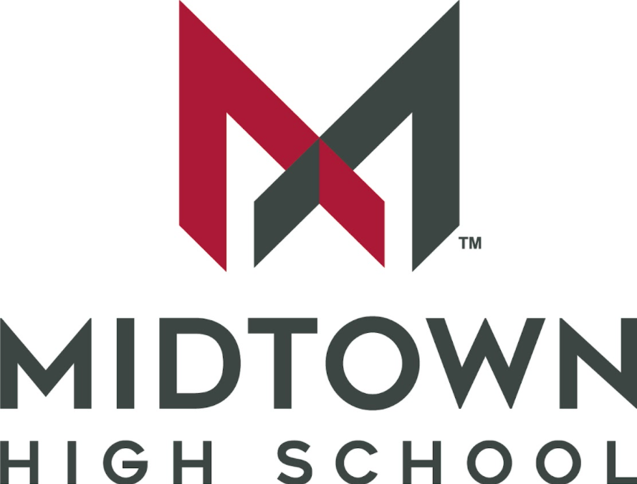

Receipt of Syllabus
Course Name: Biology
Teacher Name: Christie Lowell

______________________________ __________________________________
Student Signature Parent/Guardian Signature

______________________________ __________________________________
Date Date

